Implement Client Script & UI Policy (Incident)
Phase 4: Project Planning Phase
Item | Details
Project Name | Implement Client Script & UI Policy (Incident)
Platform | ServiceNow
Target Table | Incident [incident]
Team ID | SWTID-2026-6974
Team Size | 5 members
Total Project Time | 3 hours
Sprints | 3 sprints of 1 hour each
Total Story Points | 25

1. Introduction
The Project Planning Phase turns the requirements and design from the earlier phases into a schedule the team can follow. It lists the work as a product backlog, groups it into sprints, estimates each item in story points, and assigns every item to team members. This project is a short micro project, so the plan is built around a total of 3 hours and a team of 5.
The plan covers the five configuration tasks from the project guide (UI Policy, UI Policy Action for Urgency, onChange, onSubmit and onCellEdit scripts), the testing activities, and the final documentation and demonstration.

2. Team and Responsibilities
Replace the placeholders with the actual names of the team members.
Member | Name | Main Responsibility
Team Member 1 | Balasanjai S | UI Policy creation, onSubmit Client Script, reverse condition testing
Team Member 2 | Abisek M | UI Policy Action for Assignment group, onCellEdit Client Script (with Member 5), reverse condition testing
Team Member 3 | Kavi Balan K | UI Policy Action for Urgency, mandatory and successful-save testing, list and form update testing
Team Member 4 | Noorul Ameen I | onChange Client Script, mandatory and successful-save testing, list and form update testing
Team Member 5 | Umar HALITH | onChange Client Script (with Member 4), onCellEdit support, documentation and demonstration

3. Product Backlog, Sprint Schedule and Estimation
Each user story is estimated in story points, where 1 is a very small task and 3 is the largest task in this project. Priority is High for the controls that enforce the main business rules and Medium for supporting checks.
Sprint | Functional Requirement (Epic) | User Story No. | User Story / Task | Story Points | Priority | Team Members
1 | Field Control (UI Policy) | USN-1 | Create the High Impact Control UI Policy on Incident with condition Impact is 1 - High, Reverse if false and On load | 3 | High | Member 1
1 | Field Control (UI Policy) | USN-2 | Add the UI Policy Action on Assignment group with Mandatory set to True | 2 | High | Member 2
1 | Field Control (UI Policy) | USN-3 | Add the UI Policy Action on Urgency with Read-only set to True and Visible left alone | 2 | High | Member 3
1 | Automation (Client Script) | USN-4 | Create the onChange script on Impact that sets Urgency to High and shows a message | 3 | High | Members 4, 5
2 | Validation (Client Script) | USN-5 | Create the onSubmit script that blocks the save when Impact is High and Assigned to is empty | 3 | High | Member 1
2 | List Control (Client Script) | USN-6 | Create the onCellEdit script on State that shows an alert and cancels the list edit | 2 | Medium | Members 2, 5
2 | Testing | USN-7 | Test mandatory enforcement (save blocked with error) and successful save with Assigned to filled | 3 | High | Members 3, 4
3 | Testing | USN-8 | Test the reverse condition by changing Impact from High to Medium | 2 | Medium | Members 1, 2
3 | Testing | USN-9 | Test list edit blocking and the form-based State update | 2 | Medium | Members 3, 4
3 | Final Delivery | USN-10 | Compile the project documentation and prepare the demonstration with screenshots | 3 | Medium | Member 5 (all review)

Total: 10 user stories and 25 story points.

4. Sprint Planning

4.1 Sprint Summary
Sprint | Goal | Total Story Points | Duration | Story Points Completed | Sprint End
Sprint 1 | Build the UI Policy, both UI Policy Actions and the onChange script | 10 | 1 hour | 10 | End of Hour 1
Sprint 2 | Build the onSubmit and onCellEdit scripts and test save validation | 8 | 1 hour | 8 | End of Hour 2
Sprint 3 | Complete the remaining tests and finish the documentation and demo | 7 | 1 hour | 7 | End of Hour 3
Total |  | 25 | 3 hours | 25

Sprint start and end dates are not filled in because the project ran as one continuous 3-hour session. Add the dates in the header of this document if your submission needs them.

4.2 Hour-by-Hour Plan
Time | Sprint | Focus | Outcome
Hour 1 | Sprint 1 | Log in with admin access, create the High Impact Control UI Policy and its two UI Policy Actions, then add the onChange script | Impact High makes Assignment group mandatory and Urgency read-only and set to High
Hour 2 | Sprint 2 | Add the onSubmit and onCellEdit scripts, then test the blocked save and the successful save | Save is blocked without Assigned to; list edits of State are refused
Hour 3 | Sprint 3 | Test the reverse condition, list edit blocking and the form update, then compile the documentation and demo | All behaviours verified and the deliverables are ready

5. Velocity and Burndown

5.1 Velocity
The team completed 25 story points across 3 sprints of 1 hour each.
- Average velocity = 25 story points ÷ 3 sprints = about 8.3 story points per sprint (per hour).
- Per member = 25 story points ÷ 5 members = 5 story points per member on average.
- Sprint velocity = 10, 8 and 7 story points in Sprints 1, 2 and 3.

5.2 Burndown
Point in Time | Story Points Remaining | Story Points Completed
Start of project | 25 | 0
End of Sprint 1 (Hour 1) | 15 | 10
End of Sprint 2 (Hour 2) | 7 | 18
End of Sprint 3 (Hour 3) | 0 | 25

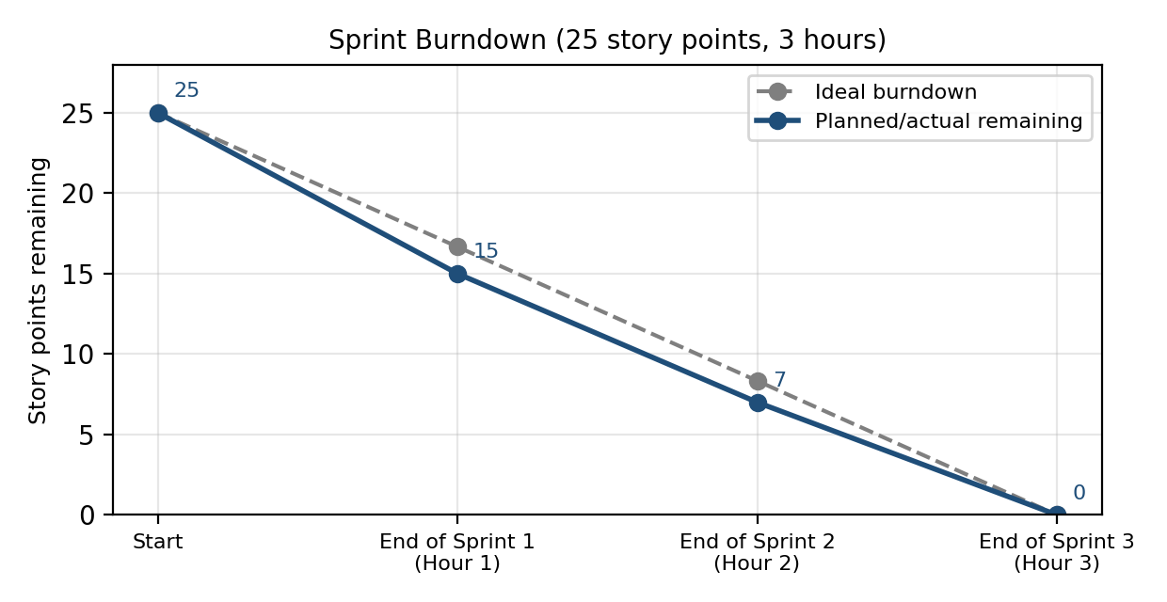

6. Risks and Mitigation
Risk | Impact | Mitigation
Project guide mixes Assignment group and Assigned to (the UI Policy makes Assignment group mandatory, the onSubmit script and tests use Assigned to) | Testers may expect the wrong field to be enforced | State both rules clearly in the test cases: Assignment group by the UI Policy, Assigned to by the onSubmit script
The onChange script in the text uses addInfoMessage, while the screenshot shows showFieldMsg | Different messages appear depending on which version is used | Use one version, and keep the same message in the test and the documentation
The onCellEdit script in the text calls callback(false), while the screenshot calls callback(false, oldValues) | List edit may not revert cleanly in some cases | Use the screenshot version and confirm State stays unchanged in USN-9
Client-side controls do not cover API, import or server-side updates | Incomplete data can still arrive through those channels | Record a server-side Business Rule or Data Policy as a future enhancement
Only 3 hours are available | Testing or documentation may be rushed | Keep the sprints small and run tests in parallel by pairing members

7. Conclusion
The plan splits the project into 10 user stories worth 25 story points and delivers them in three 1-hour sprints with a team of five. Sprint 1 builds the form controls, Sprint 2 adds validation and list control, and Sprint 3 completes testing and documentation. The velocity of about 8.3 story points per hour and the burndown to zero show that the scope fits within the 3 hours consumed. The next phase covers development and execution.

